The Lord’s Prayer

**Our Father, who art in heaven, hallowed be thy name. Thy kingdom come, Thy will be done on earth as it is in heaven. Give us this day our daily bread and forgive us our trespasses, as we forgive those who trespass against us. And lead us not into temptation, but deliver us from evil. For thine is the kingdom, and the power, and the glory, forever. Amen.**

Prayer of Consecration

Breaking Bread

Prayer after Communion

**Eternal God, we give you thanks for this holy mystery in which you have given yourself to us. Grant that we may go into the world in the strength of your Spirit, to give ourselves for others, in the name of Jesus Christ our Lord. Amen.**

*Singing Our Faith **# 374** (vs. 1 & 4) *“Standing on the Promises”*

*Blessing and Dismissal

*Postlude

**Scatter to Serve God & Neighbor**

***Welcome to all!*** *We gather to praise God for the innumerable blessings given to us and to grow deeper in the Spirit. Joyfully, let us lift our hearts to God.*



***DIRECTORY OF CHESTNUT HILL UNITED METHODIST CHURCH***

|  |  |
| --- | --- |
| Adam J. White | Minister |
| Sharon Mayhew | Director of Music |
| Monica Campbell | Administrative Assistant |
| Judy Martin | Bookkeeper |
| Judy Robertson  Elizabeth Nichols | Lay Leader  Missionary in Henry County |



*C* *hestnut Hill*

***United Methodist Church***



*Making disciples of Jesus Christ   
for the transformation of the world.*

*You are welcome at Chestnut Hill UMC.*

4660 Fort Avenue ~ Lynchburg, Virginia 24502

Church: 434-239-8423

Minister’s Cell: 434-944-7723, Minister’s Email: awhite@ves.org

Email: [chestnuthillumc@comcast.net](mailto:chestnuthillumc@comcast.net)

On the Web at chestnuthillumc.net

Find us on Facebook: Chestnut Hill United Methodist Church

**

*Chestnut Hill United Methodist Church*

10:30 a.m. ~ October 5, 2025 ~ Seventeenth Sunday after Pentecost

*World Communion Sunday*

Our ministry vision for the Virginia Annual Conference is ***“to be***

***disciples of Jesus Christ who are lifelong learners, who influence others to serve.”***

***Welcome! Join us in worshiping God!***

Prelude

Welcome and Ministry Announcements

*Welcome in the name of Christ our Lord. Please register your attendance, printing your name, address, phone, and email, on the attendance pad provided on your pew. Thank you for silencing cell phones as we gather to worship God.*

Invocation

*Greeting

Lord, let me live from day to day,  
**In such a self-forgetful way,**That even when I kneel to pray,  
**My prayer shall be for others.**

Yes, others, Lord, yes, others,  
**Let this my motto be;**Help me to live for others,  
**That I may live like Thee.**

Help me in all the work I do  
**To ever be sincere and true,**And know that all I’d do for you  
**Must needs be done for others.**

Let “Self” be crucified and slain  
**And buried deep, nor rise again**  
And may all efforts be in vain,  
**Unless they be for others.**

So when my work on earth is done,  
**And my new work in heaven’s begun,**  
May I forget the crown I’ve won,  
**While thinking still of others.**

*Singing Our Faith **# 110** *“A Mighty Fortress Is Our God”*

Opening Prayer

**Almighty and everlasting God, you are always more ready to hear than we to pray, and to give more than we either desire or deserve: Pour upon us the abundance of your mercy, forgiving us those things of which our conscience is afraid, and giving us those good things for which we are not worthy to ask, except through the merits and mediation of Jesus Christ our Savior; who lives and reigns with you and the Holy Spirit, one God, for ever and ever. Amen.**

Greeting Friends and Neighbors

Prayer of Illumination

**Gracious God,** **in our tiredness and distraction,** **help us to focus our hearts on you.** **Bring life to dry bones,** **and refresh us through your living Word today.** **Amen.**

Scripture Lesson Luke 17:5-10

The Word of God for the people of God.

**Thanks be to God.**

Singing Our Faith **# 617** *“I Come with Joy”*

The Good News ***“We Were Made for This”***

Bringing Forward God’s Tithes and Our Gifts

*Doxology **# 95 Praise God from whom all blessings flow; praise him, all Creatures here below;** **praise him above, ye heavenly host; praise Father, Son, and Holy Ghost. Amen.**

*Prayer of Thanksgiving

Sharing of Joys and Concerns

***\*\*Calendar \*\****

|  |  |  |
| --- | --- | --- |
| Sunday, 10/5 | 10:30 a.m. | *Worship/****Administrative Board meeting*** (Approval of 2026 Budget) |
|  |  |  |
| Friday, 10/10 |  | *Church Office Closed* |

***\*\*Looking Ahead on the Calendar \*\****

|  |  |  |
| --- | --- | --- |
| Monday, 10/13 |  | *Columbus Day*  *Church Office Closed* |
|  | 7:00 p.m. | *Wesleyan Group @ Jessen Home* |
|  |  |  |
| Sunday, 10/19 | 10:00 a.m. | *Choir* |

**For the Grocery Cart:**

**October ~ *Side dishes for a holiday meal***; stuffing, cranberry sauce, instant potatoes, canned vegetables, etc.*Place donations in the grocery cart, located in the Commons*.



**Birthdays Coming Up: (October) 9-**Owen Stinnette, (99th birthday). **11**-Landen Glass.

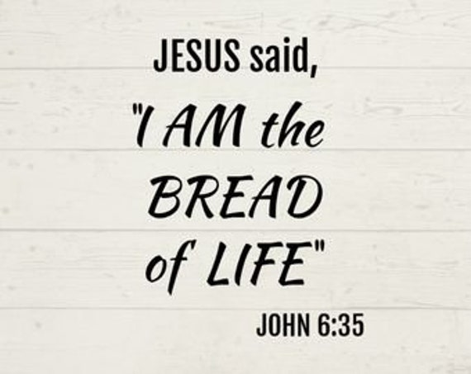

***\*\*Calendar \*\****

|  |  |  |
| --- | --- | --- |
| Sunday, 10/5 | 10:30 a.m. | *Worship/****Administrative Board meeting*** (Approval of 2026 Budget) |
|  |  |  |
| Friday, 10/10 |  | *Church Office Closed* |

***\*\*Looking Ahead on the Calendar \*\****

|  |  |  |
| --- | --- | --- |
| Monday, 10/13 |  | *Columbus Day*  *Church Office Closed* |
|  | 7:00 p.m. | *Wesleyan Group @ Jessen Home* |
|  |  |  |
| Sunday, 10/19 | 10:00 a.m. | *Choir* |

**For the Grocery Cart:**

**October ~ *Side dishes for a holiday meal***; stuffing, cranberry sauce, instant potatoes, canned vegetables, etc.*Place donations in the grocery cart, located in the Commons*.



**Birthdays Coming Up: (October) 9-**Owen Stinnette, (99th birthday). **11**-Landen Glass.

